Application for internship program

Name of Applicant: ____________________________________________ Age: _______

Applicant or Guardian’s Contact Information

Address: ________________________________________________________________

Home Phone: _________________Cell: _____________ Email: ____________________

Emergency Contact Information

Name: ___________________________________ Relationship: ___________________

Home Phone: _____________________________________Cell: ___________________

Internship Area of Interest (Label three in order of preference):
__ Directing | __Props | __ Stage Management
__ Lighting Design | __ Sound Design | __ Set Design
__ Costume Design | __ Make Up

Briefly explain your reasons for applying to the internship program.
Please include specific objectives and expected benefits of the internship

________________________________________________________________________________________________________________________________________________________________________________________________________________________________________________________________________________________________________________________________________________________________________________________________________________________________________________________________________________________________________________________________________________________________________________________________________________________________________________________________________________________________________________________________________________________________________________________________________________________

Please list any scheduling conflicts

________________________________________________________________________________________________________________________________________________________________________________________________________________________________________________________________________________________________________________________________________________________________________
Statement of understanding of the conditions of the Internship

I understand that, should I be accepted as an intern, the following conditions will apply:

a) I understand that I am expected to attend all required dates. If I have conflicts, I will get them approved prior to accepting my position.

b) Part of an internship includes observation as well as hands on work. I will communicate efficiently with my mentor and the intern coordinator throughout the process.

c) I will conduct myself in a professional manner with peers and adult staff.

Signed: _________________________________ Date: ___________________

Parent or Guardian Signature: _______________ Date: ___________________

Managing Intern Positions

Stage Manager Intern

The stage manager intern will work side by side with a stage manager and two assistant stage managers. Interns will assist the stage manager with regular rehearsal duties as well as work backstage during the show

Directing Intern Positions

Directing Intern

Directing interns will work directly with and receive mentorship and training from the production director. Interns will observe the directing team and in some instances participate in the process of blocking, character work and overseeing the overall concept of the story being told. The directing intern will keep track of all blocking notes and have some opportunities to work directly with the actors.

Choreography Intern

Choreography interns will work directly with and receive mentorship and training from the choreographer. Interns will observe the choreography team and in some instances participate in the process of teaching dances, taking notes, fixing choreography problems and overseeing the quality of the choreography.

Designing Intern Positions
Lighting Intern
The lighting intern will work directly with a professional lighting designer and educator. The intern will observe and in some instances assist the lighting designer in creating the look of the show. The intern will help hang, focus and work lights during the production

Sound Intern
The sound intern will work directly with a professional sound designer and educator. The intern will observe and in some
instances assist the sound designer with creating the sound for the show. The sound intern assist with body microphones, sound set up and problem solving during the show.

Costume Intern
The costume intern will observe and work directly with a professional costume designer and wardrobe staff. The intern will learn about creating and organizing the looks of the costumes. The intern will assist with maintaining the quality of the production and quick changes during performances

Set Intern
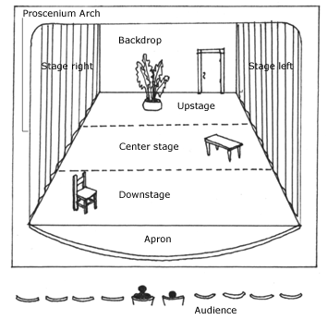
The Set Intern will work with the set designer and painter in creating the look of the production. The intern will observe and assist with the creation of the set. They will learn design elements, building elements and safey elements of the set process

Prop Intern
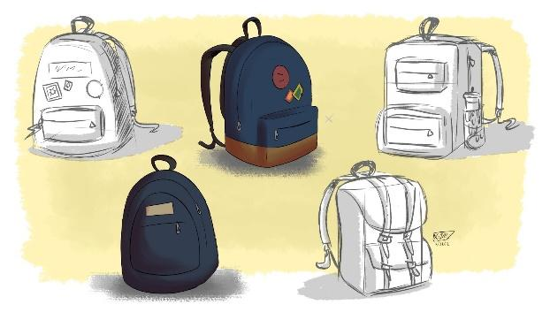
The Prop Intern will work with the prop designer in gathering, making and organizing all of the props for the sh ow. The Intern will also work with the stage crew in tracking props during performances and keeping them organized.

Make-up Intern

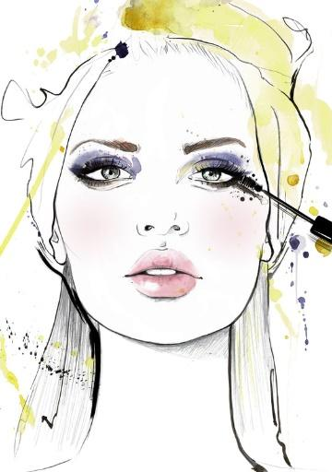
The Make-up Intern will work with the hair and make-up crew in designing those elements of the performance. The intern will assist with applying make-up and hair for each performance.

